EXPERIMENT NO : 2

AIM: Build a simple network topology and configure it for static routing protocol using packet tracer (GNS3).

What is GNS3?
GNS3 is a Graphical Network Simulator that allows emulation of complex networks. You may be familiar with VMware or Virtual PC that are used to emulate various operating systems in a virtual environment. These programs allow you to run operating systems such as Windows XP Professional or Bunt Linux in a virtual environment on your computer

Ring topology : Ring topology refers to a specific kind of network setup in which devices are connected in a ring and pass information to or from each other according to their adjacent proximity in the ring structure. This type of topology is highly efficient and handles heavier loads better than bus topology.

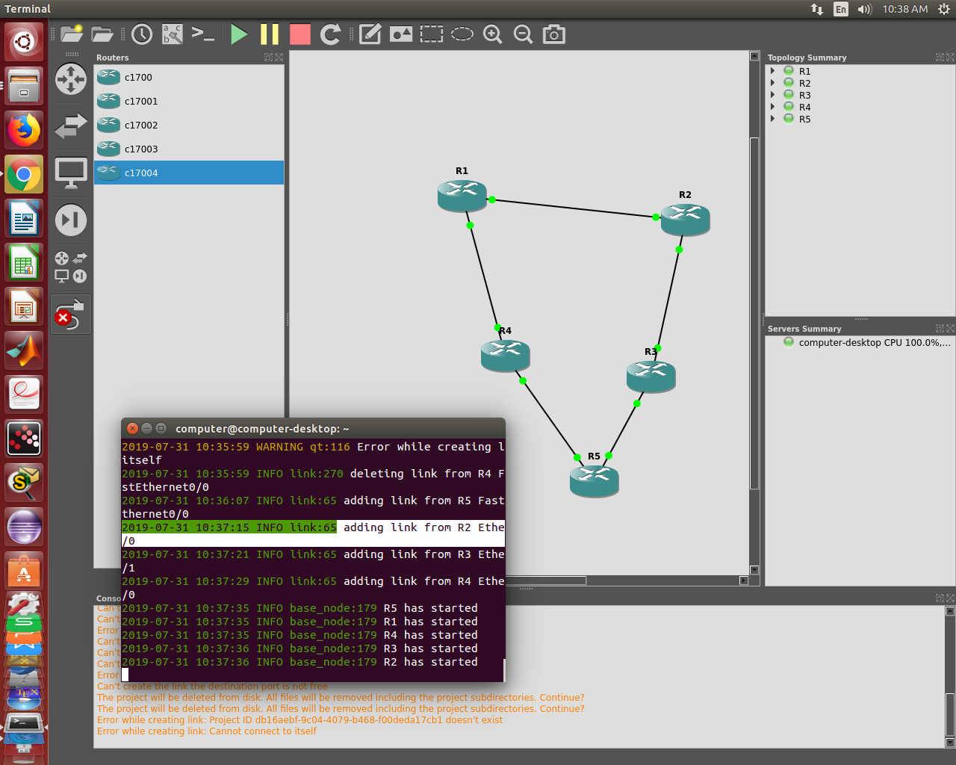
Bus Topology : A bus topology is a topology for a Local Area Network (LAN) in which all the nodes are connected to a single cable. The cable to which the nodes connect is called a "backbone". If the backbone is broken, the entire segment fails. Bus topologies are relatively easy to install and don't require much cabling compared to the alternatives.

Advantages:
- It works well when you have a small network.
- It's the easiest network topology for connecting computers or peripherals in a linear fashion.
- It requires less cable length than a star topology.

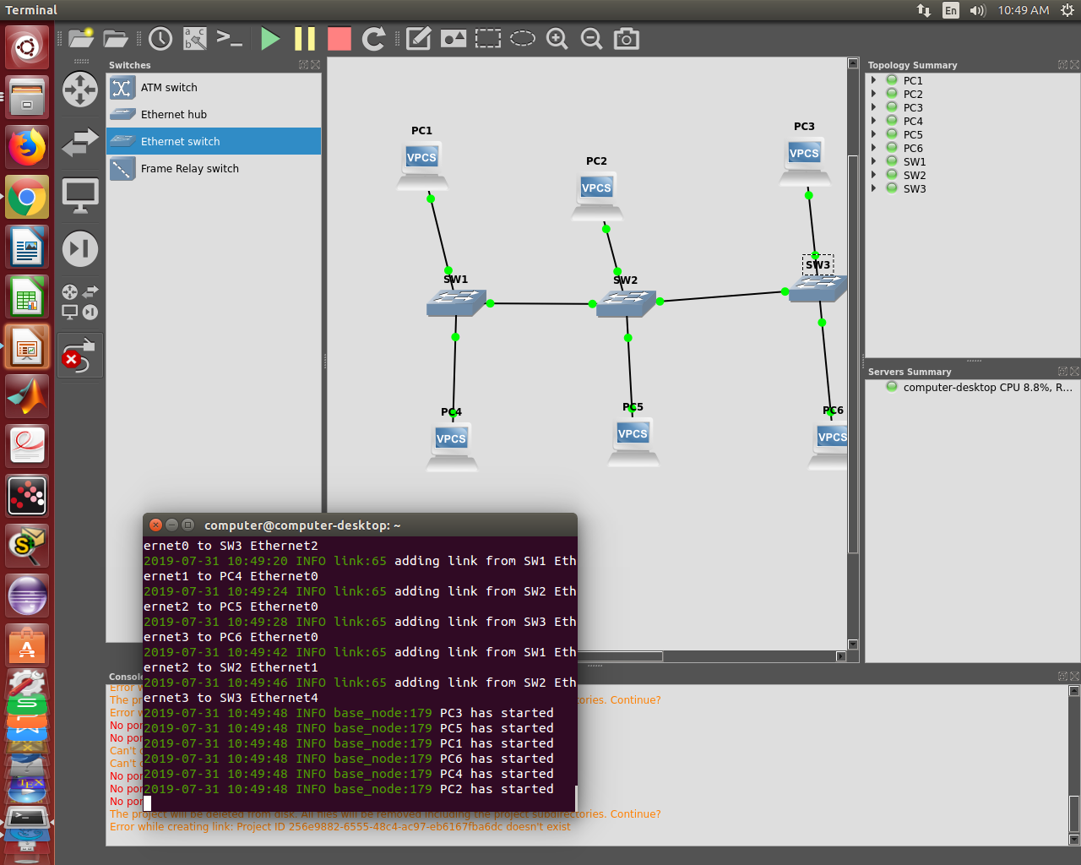

Star Topology : A star topology is a topology for a Local Area Network (LAN) in which all nodes are individually connected to a central connection point, like a hub or a switch. A star takes more cable than e.g. a bus, but the benefit is that if a cable fails, only one node will be brought down.

Avantages:
- Centralized management of the network, through the use of the central computer, hub, or switch.
- Easy to add another computer to the network.
- If one computer on the network fails, the rest of the network continues to function normally.

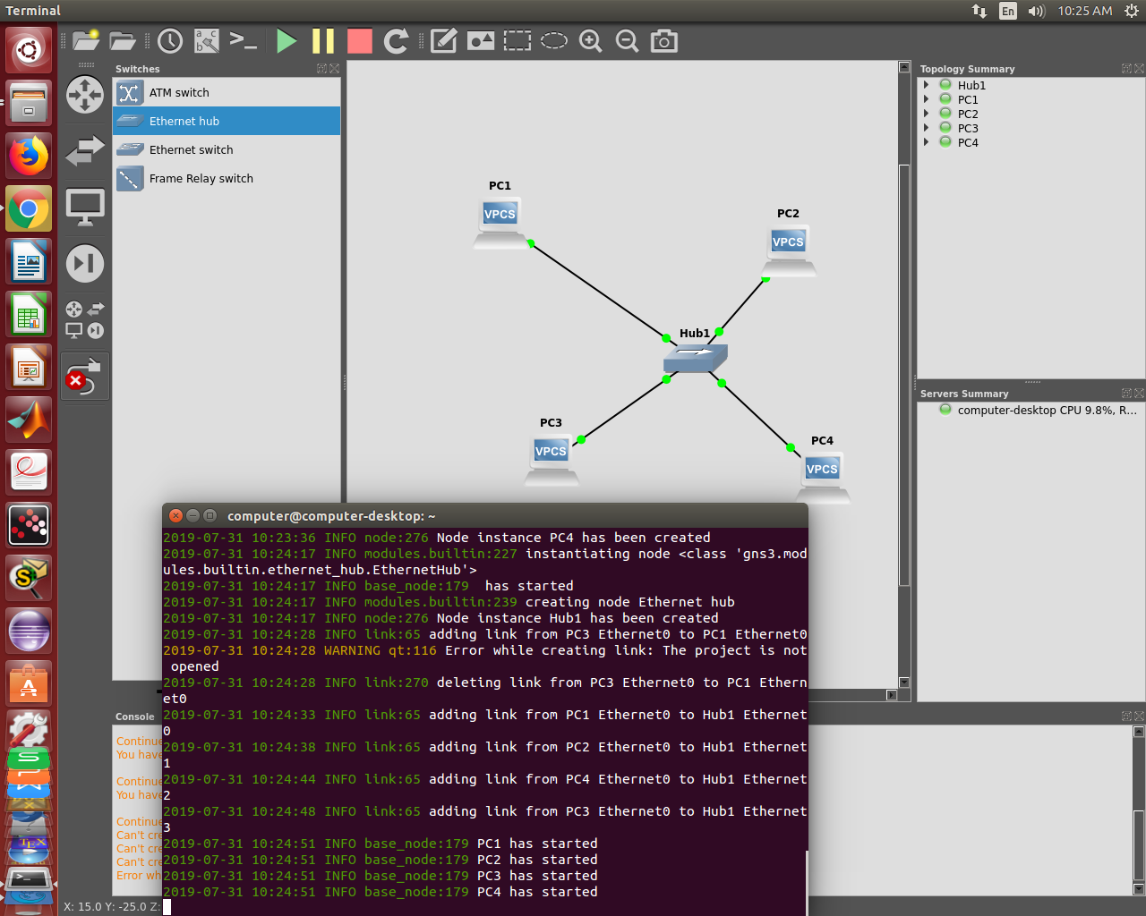

Mesh Topology: A network setup where each computer and network device is interconnected with one another, allowing for most transmissions to be distributed even if one of the connections go down. It is a topology commonly used for wireless networks. Below is a visual example of a simple computer setup on a network using a mesh topology.

Advantages:
- Manages high amounts of traffic, because multiple devices can transmit data simultaneously.
- A failure of one device does not cause a break in the network or transmission of data.
- Adding additional devices does not disrupt data transmission between other devices.

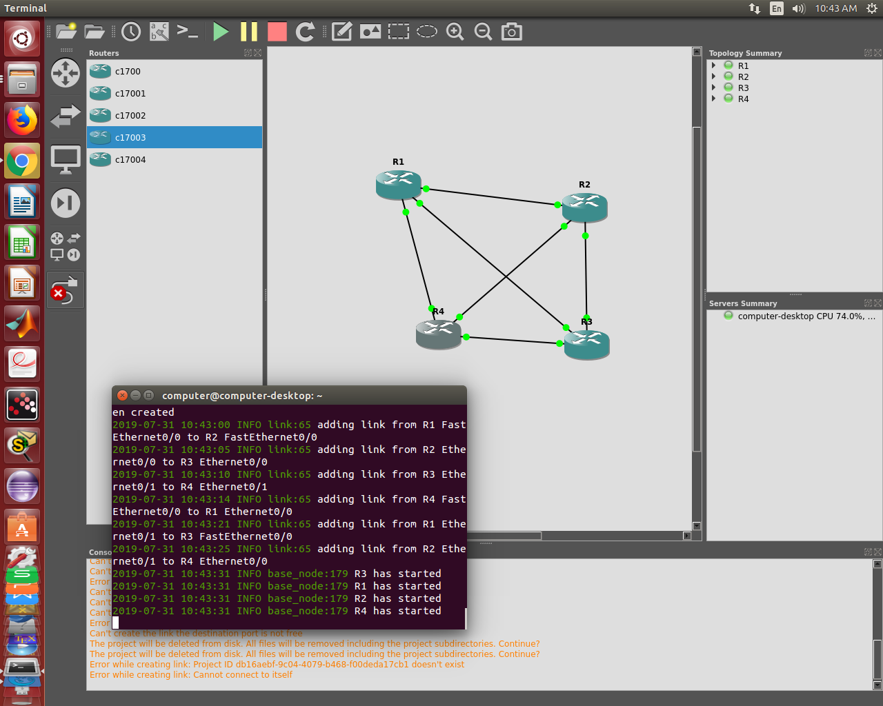
Static routing protocol using packet tracer(GNS3):
It is a type of network routing technique. Static routing is not a routing protocol; instead, it is the manual configuration and selection of a network route, usually managed by the network administrator. It is employed in scenarios where the network parameters and environment are expected to remain constant.
Static routing is only optimal in a few situations. Network degradation, latency and congestion are inevitable consequences of the non-flexible nature of static routing because there is no adjustment when the primary route is unavailable.
Advantages:
- Static routing causes very little load on the CPU of the router, and produces no traffic to other routers.
- Static routing leaves the network administrator with full control over the routing behaviour of the network.
- Static Routing Is very easy to configure on a small networks.

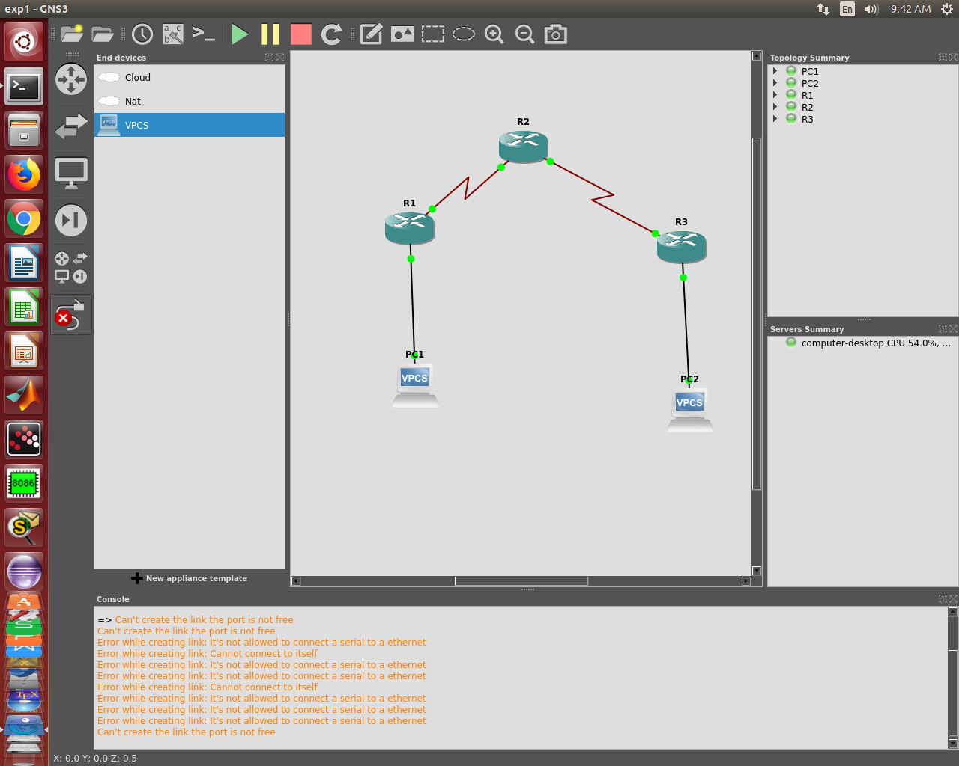
Conclusion :
Thus we studied about different network topologies and configure it for static routing protocol using GNS3

